VELLORE INSTITUTE OF TECHNOLOGY, VELLORE
QUIZ II
QUESTION PAPER
- Given an array of element 5, 7, 9, 1, 3, 10, 8, 4. Which of the following is the correct sequences of elements after inserting all the elements in a min-heap?
- 1,4,3,9,8,5,7,10
- 1,3,4,5,8,7,9,10
- 1,3,7,4,8,5,9,10
- 1,3,4,5,7,8,9,10
- Find the postorder traversal of the binary tree shown below.
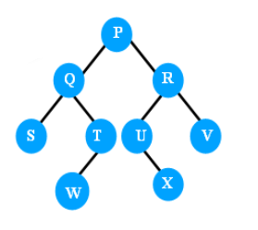
- P Q R S T U V W X
- W R S Q P V T U X
- S W T Q X U V R P
- S T W U X V Q R P
- What would be the DFS traversal of the given Graph?
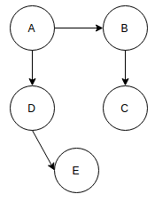
- ABCED
- AEDCB
- EDCBA
- ADEBC
- The keys 36,18, 72, 43, 6, 10, 5 and 15 are inserted into an initially empty hash table of length 8 using linear probing with hash function h(k) = k mod tablesize. Find the location of each value in the resultant hash table?
- 4,2,0,3,6,2,5,7
- 4,2,0,3,6,5,7,1
- 4,2,0,3,6,5,1,7
- 4,2,0,3,6,1,5,7
- 4,2,0,3,6,1,7,5
- 4,2,0,3,6,7,5,1
- 4,2,0,3,6,7,1,5
- A graph in which all vertices have equal degree is known as…?
- Regular graph
- Multi graph
- Simple graph
- Complete graph
- To implement Dijkstra’s shortest path algorithm on unweighted graphs so that it runs in linear time, the data structure to be used is:
- Queue
- Stack
- Heap
- B Tree
- The keys 18,41,22,44,59,32,31 and 73 are inserted into an initially empty hash table of length 13 using Double Hashing with hash function h(k) = k mod tablesize and d(k)=7-k mod 7. Find the location of each value in the resultant hash table?
- 5, 2, 9, 10, 7, 6, 0, 8
- 5, 2, 9, 10, 7, 6, 8, 0
- 5, 2, 9, 10, 6, 7, 8, 0
- 5, 2, 9, 10, 6, 7, 0, 8
- 5, 2, 9, 4, 7, 6, 5, 8

- In delete operation of AVL, we need inorder successor (or predecessor) of a node when the node to be deleted has both left and right child as non-empty. Which of the following is true about inorder successor needed in delete operation?
- Inorder Successor is always a leaf node
- Inorder successor is always either a leaf node or a node with empty left child
- Inorder successor may be an ancestor of the node
- Inorder successor is always either a leaf node or a node with empty right child
- The pre-order and in-order are traversals of a binary tree are T M L N P O Q and L M N T O P Q. Which of following is post-order traversal of the tree?
- L N M O Q P T
- N M O P O L T
- L M N O P Q T
- O P L M N Q T
- The time complexity of computing the transitive closure of a binary relation on a set of n elements is known to be:
- O(n)
- O(nLogn)
- O(n ^ (3/2))
- O(n^3)

